**Revords Launcher Application**

**Subtitle: -** A Launcher app for Kiosk Mode.

**Date**: - 03/06/2024

* **Introduction: -**
  + I have developed a Launcher application using flutter technology that offers users a streamlined way to access and manage their installed applications. This launcher allows users to add their preferred applications to a custom launcher interface.
  + One of the standout features of this launcher application is its ability to operate in Kiosk mode. This mode restricts the device to running only the specified applications, providing a focused and secure environment.
  + Importantly, this launcher application will be available into **Tablets only (Android).**
* **Key Features: -**

1. **Easily Access Installed Applications:**
   * The launcher allows users to effortlessly view and manage all installed applications on their system tablet.
2. **Seamless Integration with Kiosk mode:**
   * Users can add selected applications to the Kiosk Mode, ensuring that only designated apps are accessible.
   * This feature provides a secure and controlled environment, ideal for educational settings, where restricted access to public applications is necessary.

* **Screenshots and Descriptions: -**
* **Screenshot 1 (Home Screen): -**

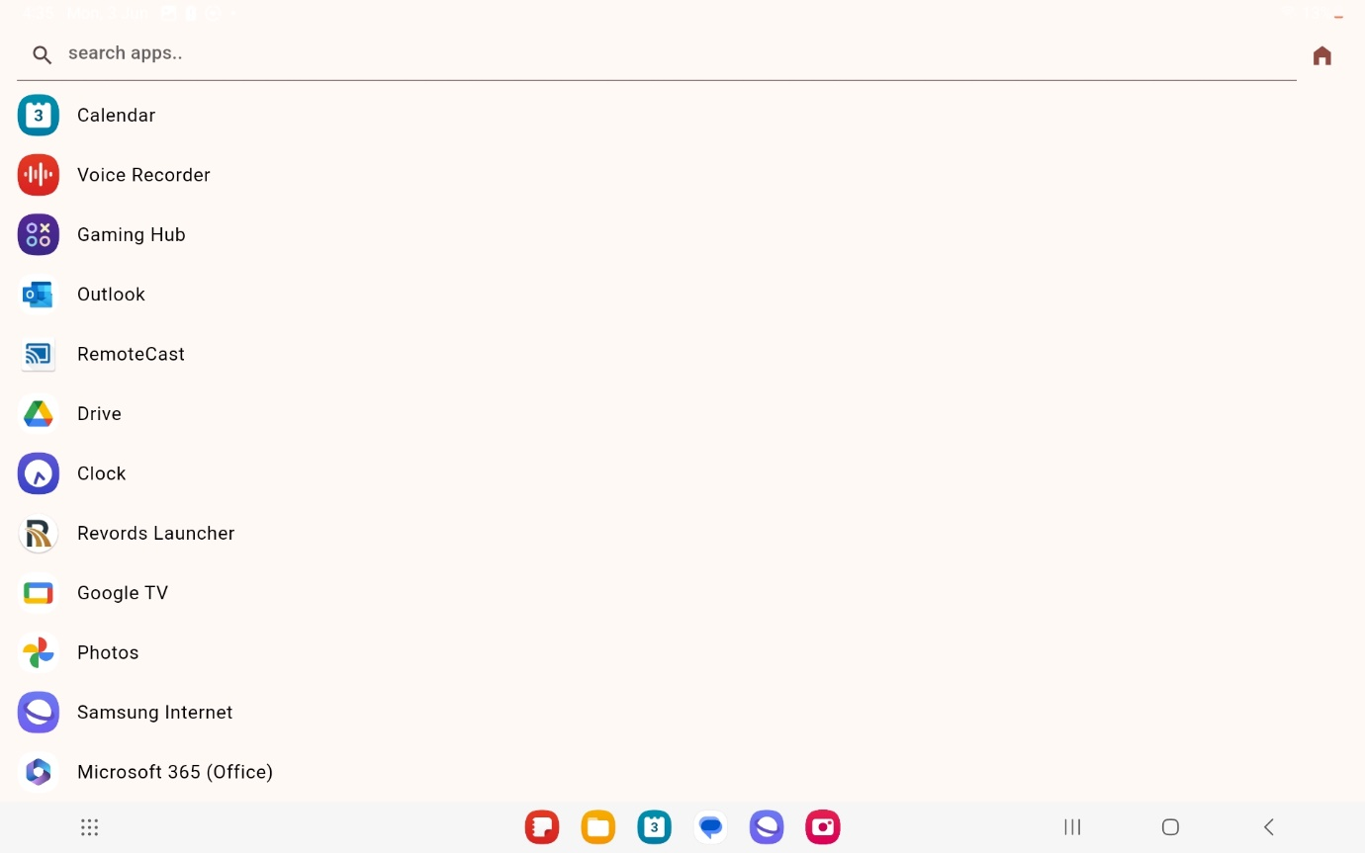

* This screen will appear first whenever user will open the application (It will be in Kiosk Mode).
* The Icon on top right corner (Home Icon) this icon will redirect to your launcher app.
* On tapping on particular application you will get the dialog box.
* **Screenshot 2: -**

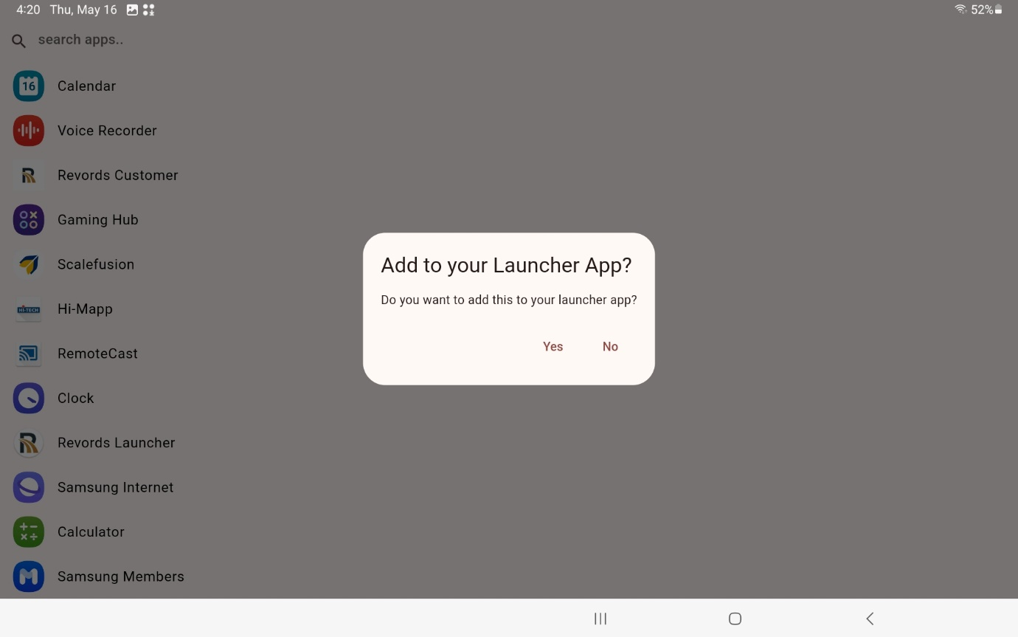

* This Page will appear whenever you will tap on any application. When you click on **“Yes”** option particular application will be added to your Launcher app.
* If you select **“No”** option the dialog box will be closed you will not navigate to any page you will stay on the same page.
* **Screenshot 3: -**

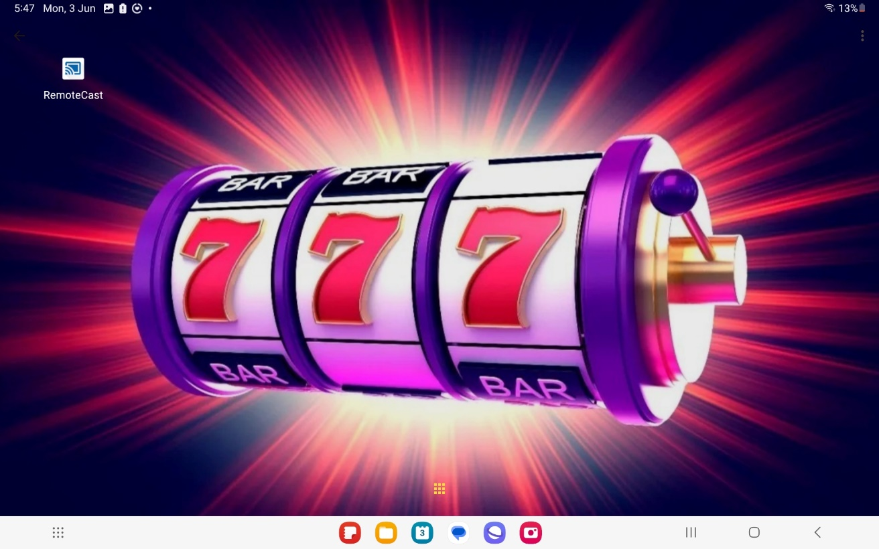

* This screen is showing after you add the application into the launcher Home Page. The “Revords Customer” app has been add into the launcher Home page.
* The icon which is visible in the middle bottom from that icon, you can add other application.
* After that you will navigate to the page i.e. (**Screenshot 1**).
* **Screenshot 4: -**

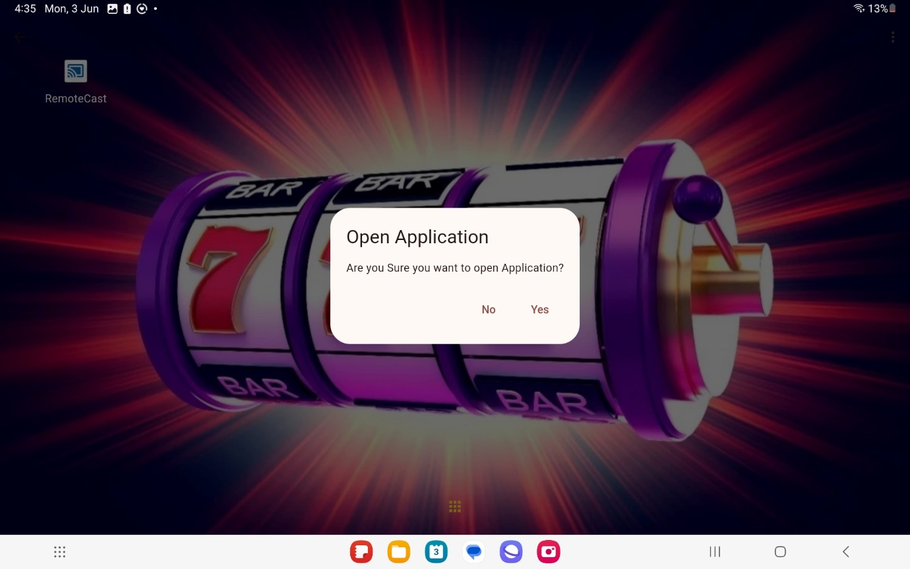

* The Dialog Box will appear whenever you try to open the application which you added into the launcher app.
* If user click on **“Yes”** the application will open but it will be out of Kiosk mode and the app will be unpinned. So, all the buttons are disabled and user will able to close the applications.
* But when you close the application which you have opened the Kiosk Mode will be activate again. And all buttons will be disabled.
* You will get to see below screenshot whenever user will exit the opened application.

(You can see the Screenshot on Next Page).

* 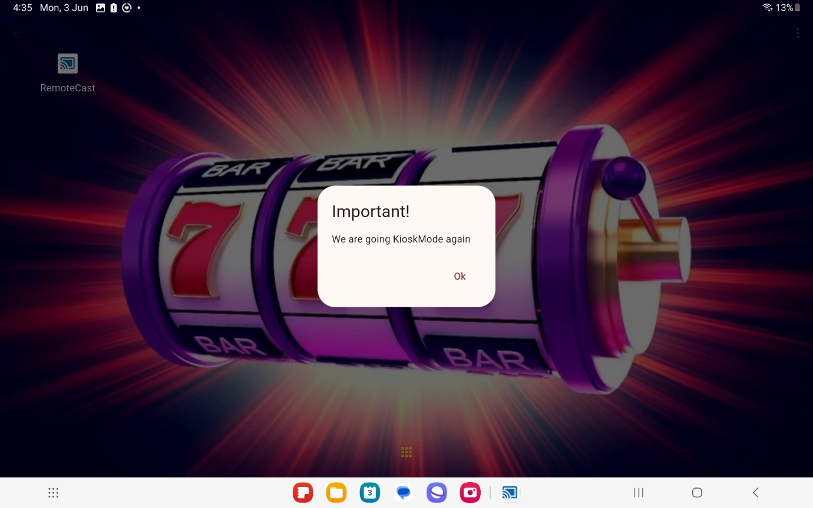This dialog box appear whenever user will close the open application,
* **Screenshot 5: -**

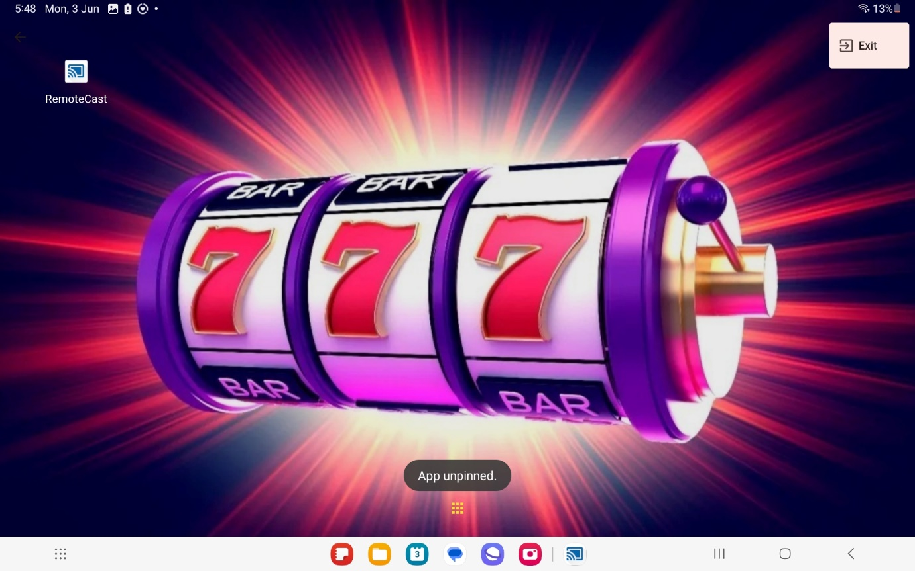

* This screenshot shows if user wants to exit the Launcher app they can exit by clicking on to the icon which is present in the top right corner.
* By clicking on to that they will ask for the security pin which user will enter if they want to exit our application.

